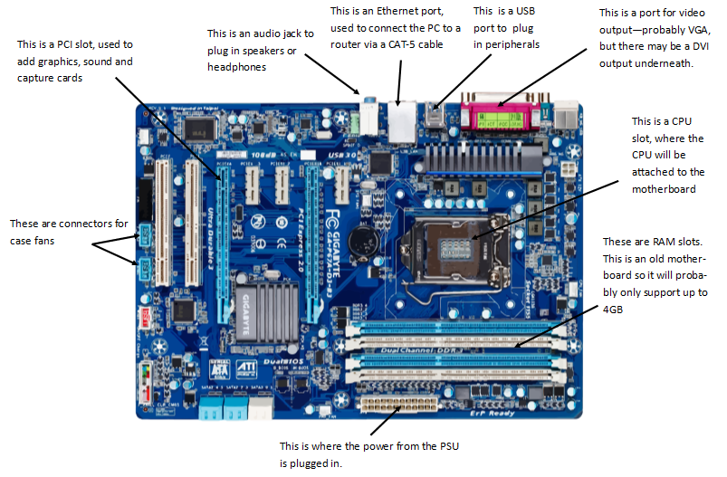

**CPU**  
The CPU is the ‘brain’ of the computer; it handles all data transfers between the HDD and RAM, and computes all the calculations needed to perform tasks and run applications.

**Motherboard**  
The motherboard is the circuit board the majority of the components sit on, such as the CPU, RAM, onboard graphics, onboard video/audio ports and slots for other components. There are also hundreds of other smaller components, such as voltage regulators, microcontrollers and the CMOS battery.

**BIOS**  
The BIOS is not technically hardware (although on older systems it was). It is a piece of software that loads the operating system, and can be used to adjust settings such as CPU clock speed and boot order. The BIOS is stored on a dedicated chip, and the data on it cannot be modified by any other software, such as the OS.

**PSU**  
The PSU, or Power Supply Unit, converts high-voltage AC power to lower voltage DC power for the components of the PC. They usually have connectors for the motherboard, GPU, and hard drives and optical drives. Some have connectors for fans, but these are usually on the motherboard or graphics card.

**Hard drives**  
The hard drive is secondary storage. It stores the OS, the user’s files, and applications and their data.  
Modern hard drives connect to the motherboard using SATA, although older drives used IDE cables.  
A computer can have more than one hard drive. SATA drives will configure themselves as they each have their own cable to the motherboard, but older IDE drives had to be configured with jumper pins, so the computer could transfer data between them properly. One drive would be the master drive, which had the OS on it, and other drives would be slave drives.

**Fans & heatsinks**  
Many components inside a computer generate heat, particularly the CPU and GPU. These components are cooled by heatsinks – pieces of metal with a large surface area transfer heat away from the CPU/GPU.   
For components that get very hot, such as powerful GPUs, heatsinks alone are not enough to prevent it from getting hot. A fan can be attached to direct air over the heatsink, transferring heat away faster.  
Fans can be attached to the case as well, to create airflow through the whole case. However, this airflow can result in large build-ups of dust over time.

**IO and Ports**  
Ports are sockets on the motherboard for connecting peripherals and cables. The most common connectors include video outputs, such as VGA, DVI or HDMI, USB, Ethernet, and 3.5mm audio ports.  
Other less common ports include serial, PS2, and MIDI ports.

**Memory**  
Computers manipulate and work with data, so the data the computer is using at any one moment needs to be accessed very quickly. The hard drive isn’t fast enough for this, so computers have RAM, Random Access Memory. RAM stores all of the data the computer is currently working with (any programs that are running, OS services, but not programs you don’t have open or files/documents on the hard drive that aren’t being used). When the computer needs some data from the hard drive, it is transferred to the RAM first before the CPU uses it. Similarly, and unsaved work resides in the RAM, and must be moved to the hard drive to save it, as all data in the RAM is lost when it has no power – it is volatile memory.  
ROM is very similar to RAM, except the contents of the ROM is read-only – it cannot be changed like the data in RAM. Also, ROM is non-volatile. ROM is used to store data essential to the functioning of the computer, such as the BIOS, and is not used during normal computer usage.  
The more RAM a computer has, the more programs it can run at once.

**Cards**  
While the majority of motherboards have everything needed for normal use onboard, the functionality of the computer can be expanded with extra boards, or cards. These cards are specialized to do a specific task, much better than the onboard systems. Common cards include graphics cards (for rendering output to the screen), network cards (for faster connection speeds between computers and to add wireless connections), and sound cards (for higher fidelity audio and more output ports).  
By far the most commonly used card is a graphics card. As we mainly interact with computers visually, having high definition, high frame rate output is important. Having a powerful GPU also speeds up video rendering, and improves video playback. The most common use of high-end GPU’s is in gaming, in which the GPU must not only output the pixels to the display, but also calculate what the scene will look like.

**IO devices**  
IO (input/output) devices allow humans and computers to exchange information. Outputs from the computer include the display (monitor), and sound (speakers or headphones), as well as things like printers, and even indicator lights. Inputs include mouse and keyboard, cameras, microphones, scanners, USB controllers and more. There are also IO devices for those that struggle or are unable to use conventional IO devices. For example, the famous physicist Stephen Hawking has neurone motor disorder and is paralyzed. He has an eye-tracking camera that allows him to enter text into the computer on his wheelchair.

**Cabling**  
Cables (a collection of two or more wires inside a single sleeve) are used to transfer power and information between various parts of a computer. The most basic cables, the cables from power buttons and indicator lights, are just two copper wires with GPIO pins on the end. Power cables often have dozens of wires and can be up to an inch thick. Data transfer cables, such as USB motherboard connectors and SATA cables also have dozens of wires inside them.  
The way these wires are braided to form the cable is important to its strength, flexibility, and efficiency. Some cables are flat, with all the wires side-by-side, some are just a parallel bundle, and some have complex interwoven braids. This is important for dissipating heat in power cables (it ensures every wire has equal exposure to the air around it), and ensuring the cable can bend and flex without breaking.  
The length of cables affects signal quality, due to resistance in the wires. This is why HDMI cables cannot be longer than 10 metres.  
Not all cables use copper wires – some are silver or gold, and some are optic fibre which transmit light instead of electricity. Fibre optic can only transfer information, not power.

**Backup storage.**  
Most computers only need one hard drive to store all of their data. However, hard drives can fail and data can be lost. To prevent loss of data, information should be backed up.  
Backing up single files folders is easy. They can be copied to a USB drive, disc, or uploaded to a file server (cloud storage).  
Backing up larger amounts of data, such as photo collections, can be done in the same manner, or they can be copied to external hard drives.  
Backing up an entire hard drive is harder. The contents can be copied to another drive (external or internal) with a backup utility, or a ‘rescue image’ – a compressed .ISO file containing the contents of the hard drive – can be created.